МИНИСТЕРСТВО ОБРАЗОВАНИЯ И НАУКИ УКРАИНЫ

НАЦИОНАЛЬНЫЙ ТЕХНИЧЕСКИЙ УНИВЕРСИТЕТ  
«ХАРЬКОВСКИЙ ПОЛИТЕХНИЧЕСКИЙ ИНСТИТУТ»

Кафедра «Программной инженерии и информационных технологий управления»

Расчетно-графическое задание  
по дисциплине «Дискретная математика»

(Вариант 12)

Выполнил:

студент группы КН-36А

Кулик В. В.

Проверил:

проф., к.т.н. Гужва В. А.

Харьков 2017

СОДЕРЖАНИЕ

1. Составить матрицы смежности и инциденций.

2. Определить количество путей в графе длинной 3.

3. Построить конденсацию графа.

4. Найти кратчайшие расстояния от вершины Х1 до Х13 методом Дейкстры.

5. Найти кратчайшие расстояния от вершины Х1 до Х13 методом Флойда.

6. Найти кратчайшие расстояния между всеми парами вершин методом Данцига.

7. Найти максимальный поток от вершины Х1до Х13.

8. Найти минимальный поток от вершины Х1 до Х13.

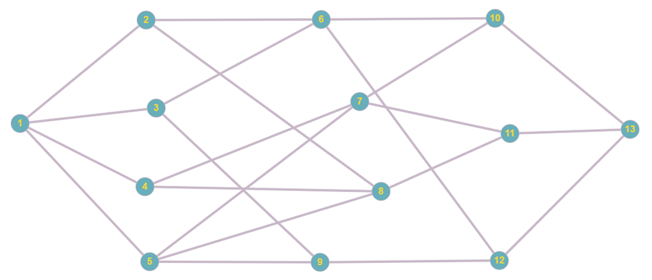

Матрица смежности для неориентированного графа:

|  |  |  |  |  |  |  |  |  |  |  |  |  |  |
| --- | --- | --- | --- | --- | --- | --- | --- | --- | --- | --- | --- | --- | --- |
|  | X1 | X2 | X3 | X4 | X5 | X6 | X7 | X8 | X9 | X10 | X11 | X12 | X13 |
| X1 | 0 | 1 | 1 | 1 | 1 | 0 | 0 | 0 | 0 | 0 | 0 | 0 | 0 |
| X2 | 1 | 0 | 0 | 0 | 0 | 1 | 0 | 1 | 0 | 0 | 0 | 0 | 0 |
| X3 | 1 | 0 | 0 | 0 | 0 | 1 | 0 | 0 | 1 | 0 | 0 | 0 | 0 |
| X4 | 1 | 0 | 0 | 0 | 0 | 0 | 1 | 1 | 0 | 0 | 0 | 1 | 0 |
| X5 | 1 | 0 | 0 | 0 | 0 | 0 | 1 | 1 | 1 | 0 | 0 | 0 | 0 |
| X6 | 0 | 1 | 1 | 0 | 0 | 0 | 0 | 0 | 0 | 1 | 0 | 1 | 0 |
| X7 | 0 | 0 | 0 | 0 | 1 | 0 | 0 | 0 | 0 | 0 | 1 | 0 | 0 |
| X8 | 0 | 1 | 0 | 1 | 0 | 0 | 0 | 0 | 0 | 0 | 1 | 0 | 0 |
| X9 | 0 | 0 | 1 | 0 | 1 | 0 | 0 | 0 | 0 | 0 | 0 | 1 | 0 |
| X10 | 0 | 0 | 0 | 0 | 0 | 1 | 1 | 0 | 0 | 0 | 0 | 0 | 1 |
| X11 | 0 | 0 | 0 | 0 | 0 | 0 | 1 | 1 | 0 | 1 | 0 | 0 | 1 |
| X12 | 0 | 0 | 0 | 0 | 0 | 1 | 0 | 0 | 1 | 0 | 0 | 0 | 1 |
| X13 | 0 | 0 | 0 | 0 | 0 | 0 | 0 | 0 | 0 | 1 | 1 | 1 | 0 |

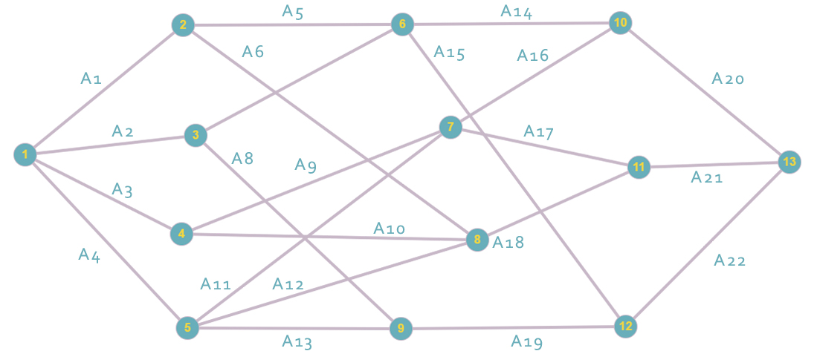

Матрица инциденций для неориентированного графа:

|  |  |  |  |  |  |  |  |  |  |  |  |  |  |  |  |  |  |  |  |  |  |  |
| --- | --- | --- | --- | --- | --- | --- | --- | --- | --- | --- | --- | --- | --- | --- | --- | --- | --- | --- | --- | --- | --- | --- |
|  | 1 | 2 | 3 | 4 | 5 | 6 | 7 | 8 | 9 | 10 | 11 | 12 | 13 | 14 | 15 | 16 | 17 | 18 | 19 | 20 | 21 | 22 |
| X1 | 1 | 1 | 1 | 1 | 0 | 0 | 0 | 0 | 0 | 0 | 0 | 0 | 0 | 0 | 0 | 0 | 0 | 0 | 0 | 0 | 0 | 0 |
| X2 | 1 | 0 | 0 | 0 | 1 | 1 | 0 | 0 | 0 | 0 | 0 | 0 | 0 | 0 | 0 | 0 | 0 | 0 | 0 | 0 | 0 | 0 |
| X3 | 0 | 1 | 0 | 0 | 0 | 0 | 1 | 1 | 0 | 0 | 0 | 0 | 0 | 0 | 0 | 0 | 0 | 0 | 0 | 0 | 0 | 0 |
| X4 | 0 | 0 | 1 | 0 | 0 | 0 | 0 | 0 | 1 | 1 | 0 | 0 | 0 | 0 | 0 | 0 | 0 | 0 | 0 | 0 | 0 | 0 |
| X5 | 0 | 0 | 0 | 1 | 0 | 0 | 0 | 0 | 0 | 0 | 1 | 1 | 1 | 0 | 0 | 0 | 0 | 0 | 0 | 0 | 0 | 0 |
| X6 | 0 | 0 | 0 | 0 | 1 | 0 | 1 | 0 | 0 | 0 | 0 | 0 | 0 | 1 | 1 | 0 | 0 | 0 | 0 | 0 | 0 | 0 |
| X7 | 0 | 0 | 0 | 0 | 0 | 0 | 0 | 0 | 1 | 0 | 1 | 0 | 0 | 0 | 0 | 1 | 1 | 0 | 0 | 0 | 0 | 0 |
| X8 | 0 | 0 | 0 | 0 | 0 | 1 | 0 | 0 | 0 | 1 | 0 | 1 | 0 | 0 | 0 | 0 | 0 | 1 | 0 | 0 | 0 | 0 |
| X9 | 0 | 0 | 0 | 0 | 0 | 0 | 0 | 1 | 0 | 0 | 0 | 0 | 1 | 0 | 0 | 0 | 0 | 0 | 1 | 0 | 0 | 0 |
| X10 | 0 | 0 | 0 | 0 | 0 | 0 | 0 | 0 | 0 | 0 | 0 | 0 | 0 | 1 | 0 | 1 | 0 | 0 | 0 | 1 | 0 | 0 |
| X11 | 0 | 0 | 0 | 0 | 0 | 0 | 0 | 0 | 0 | 0 | 0 | 0 | 0 | 0 | 0 | 0 | 1 | 1 | 0 | 1 | 0 | 0 |
| X12 | 0 | 0 | 0 | 0 | 0 | 0 | 0 | 0 | 0 | 0 | 0 | 0 | 0 | 0 | 0 | 0 | 0 | 0 | 1 | 0 | 0 | 1 |
| X13 | 0 | 0 | 0 | 0 | 0 | 0 | 0 | 0 | 0 | 0 | 0 | 0 | 0 | 0 | 0 | 0 | 0 | 0 | 0 | 1 | 1 | 1 |

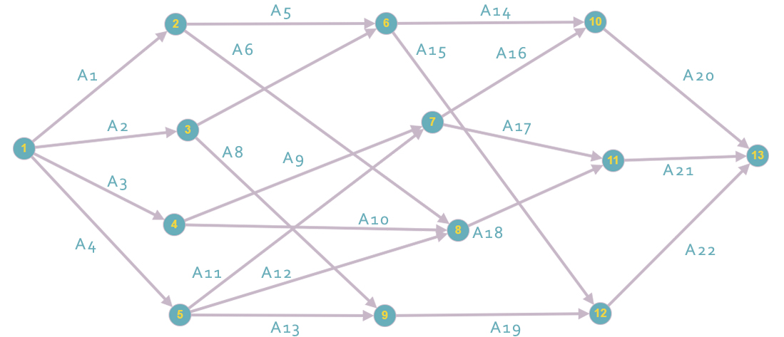

Матрица смежности для ориентированного графа:

|  |  |  |  |  |  |  |  |  |  |  |  |  |  |
| --- | --- | --- | --- | --- | --- | --- | --- | --- | --- | --- | --- | --- | --- |
|  | X1 | X2 | X3 | X4 | X5 | X6 | X7 | X8 | X9 | X10 | X11 | X12 | X13 |
| X1 | 0 | 1 | 1 | 1 | 1 | 0 | 0 | 0 | 0 | 0 | 0 | 0 | 0 |
| X2 | 0 | 0 | 0 | 0 | 0 | 1 | 0 | 1 | 0 | 0 | 0 | 0 | 0 |
| X3 | 0 | 0 | 0 | 0 | 0 | 1 | 0 | 0 | 1 | 0 | 0 | 0 | 0 |
| X4 | 0 | 0 | 0 | 0 | 0 | 0 | 1 | 1 | 0 | 0 | 0 | 0 | 0 |
| X5 | 0 | 0 | 0 | 0 | 0 | 0 | 1 | 1 | 1 | 0 | 0 | 0 | 0 |
| X6 | 0 | 0 | 0 | 0 | 0 | 0 | 0 | 0 | 0 | 1 | 0 | 1 | 0 |
| X7 | 0 | 0 | 0 | 0 | 0 | 0 | 0 | 0 | 0 | 1 | 1 | 0 | 0 |
| X8 | 0 | 0 | 0 | 0 | 0 | 0 | 0 | 0 | 0 | 0 | 1 | 0 | 0 |
| X9 | 0 | 0 | 0 | 0 | 0 | 0 | 0 | 0 | 0 | 0 | 0 | 1 | 0 |
| X10 | 0 | 0 | 0 | 0 | 0 | 0 | 0 | 0 | 0 | 0 | 0 | 0 | 1 |
| X11 | 0 | 0 | 0 | 0 | 0 | 0 | 0 | 0 | 0 | 0 | 0 | 0 | 1 |
| X12 | 0 | 0 | 0 | 0 | 0 | 0 | 0 | 0 | 0 | 0 | 0 | 0 | 1 |
| X13 | 0 | 0 | 0 | 0 | 0 | 0 | 0 | 0 | 0 | 0 | 0 | 0 | 0 |

Матрица инциденций для ориентированного графа:

|  |  |  |  |  |  |  |  |  |  |  |  |  |  |  |  |  |  |  |  |  |  |  |  |
| --- | --- | --- | --- | --- | --- | --- | --- | --- | --- | --- | --- | --- | --- | --- | --- | --- | --- | --- | --- | --- | --- | --- | --- |
|  | 1 | 2 | 3 | 4 | 5 | 6 | 7 | 8 | 9 | 10 | 11 | 12 | 13 | 14 | 15 | 16 | 17 | 18 | 19 | 20 | 21 | 22 | 23 |
| X1 | 1 | 1 | 1 | 1 | 0 | 0 | 0 | 0 | 0 | 0 | 0 | 0 | 0 | 0 | 0 | 0 | 0 | 0 | 0 | 0 | 0 | 0 | 0 |
| X2 | -1 | 0 | 0 | 0 | 1 | 1 | 0 | 0 | 0 | 0 | 0 | 0 | 0 | 0 | 0 | 0 | 0 | 0 | 0 | 0 | 0 | 0 | 0 |
| X3 | 0 | -1 | 0 | 0 | 0 | 0 | 1 | 1 | 0 | 0 | 0 | 0 | 0 | 0 | 0 | 0 | 0 | 0 | 0 | 0 | 0 | 0 | 0 |
| X4 | 0 | 0 | -1 | 0 | 0 | 0 | 0 | 0 | 1 | 1 | 0 | 0 | 0 | 0 | 0 | 0 | 0 | 0 | 0 | 0 | 0 | 0 | 0 |
| X5 | 0 | 0 | 0 | -1 | 0 | 0 | 0 | 0 | 0 | 0 | 1 | 1 | 1 | 0 | 0 | 0 | 0 | 0 | 0 | 0 | 0 | 0 | 0 |
| X6 | 0 | 0 | 0 | 0 | -1 | 0 | -1 | 0 | 0 | 0 | 0 | 0 | 0 | 1 | 1 | 0 | 0 | 0 | 0 | 0 | 0 | 0 | 0 |
| X7 | 0 | 0 | 0 | 0 | 0 | 0 | 0 | 0 | -1 | 0 | -1 | 0 | 0 | 0 | 0 | 1 | 1 | 0 | 0 | 0 | 0 | 0 | 0 |
| X8 | 0 | 0 | 0 | 0 | 0 | -1 | 0 | 0 | 0 | -1 | 0 | -1 | 0 | 0 | 0 | 0 | 0 | 1 | 0 | 0 | 0 | 0 | 0 |
| X9 | 0 | 0 | 0 | 0 | 0 | 0 | 0 | -1 | 0 | 0 | 0 | 0 | -1 | 0 | 0 | 0 | 0 | 0 | 1 | 0 | 0 | 0 | 0 |
| X10 | 0 | 0 | 0 | 0 | 0 | 0 | 0 | 0 | 0 | 0 | 0 | 0 | 0 | -1 | 0 | -1 | 0 | 0 | 0 | 1 | 0 | 0 | 0 |
| X11 | 0 | 0 | 0 | 0 | 0 | 0 | 0 | 0 | 0 | 0 | 0 | 0 | 0 | 0 | 0 | 0 | -1 | -1 | 0 | 0 | 1 | 0 | 0 |
| X12 | 0 | 0 | 0 | 0 | 0 | 0 | 0 | 0 | 0 | 0 | 0 | 0 | 0 | 0 | -1 | 0 | 0 | 0 | -1 | 0 | 0 | 0 | 1 |
| X13 | 0 | 0 | 0 | 0 | 0 | 0 | 0 | 0 | 0 | 0 | 0 | 0 | 0 | 0 | 0 | 0 | 0 | 0 | 0 | 0 | -1 | -1 | -1 |

Матрица смежности в кубе:

|  |  |  |  |  |  |  |  |  |  |  |  |  |  |
| --- | --- | --- | --- | --- | --- | --- | --- | --- | --- | --- | --- | --- | --- |
|  | X1 | X2 | X3 | X4 | X5 | X6 | X7 | X8 | X9 | X10 | X11 | X12 | X13 |
| X1 | 0 | 0 | 0 | 0 | 0 | 0 | 0 | 0 | 0 | 4 | 5 | 4 | 0 |
| X2 | 0 | 0 | 0 | 0 | 0 | 0 | 0 | 0 | 0 | 0 | 0 | 0 | 3 |
| X3 | 0 | 0 | 0 | 0 | 0 | 0 | 0 | 0 | 0 | 0 | 0 | 0 | 3 |
| X4 | 0 | 0 | 0 | 0 | 0 | 0 | 0 | 0 | 0 | 0 | 0 | 0 | 3 |
| X5 | 0 | 0 | 0 | 0 | 0 | 0 | 0 | 0 | 0 | 0 | 0 | 0 | 4 |
| X6 | 0 | 0 | 0 | 0 | 0 | 0 | 0 | 0 | 0 | 0 | 0 | 0 | 0 |
| X7 | 0 | 0 | 0 | 0 | 0 | 0 | 0 | 0 | 0 | 0 | 0 | 0 | 0 |
| X8 | 0 | 0 | 0 | 0 | 0 | 0 | 0 | 0 | 0 | 0 | 0 | 0 | 0 |
| X9 | 0 | 0 | 0 | 0 | 0 | 0 | 0 | 0 | 0 | 0 | 0 | 0 | 0 |
| X10 | 0 | 0 | 0 | 0 | 0 | 0 | 0 | 0 | 0 | 0 | 0 | 0 | 0 |
| X11 | 0 | 0 | 0 | 0 | 0 | 0 | 0 | 0 | 0 | 0 | 0 | 0 | 0 |
| X12 | 0 | 0 | 0 | 0 | 0 | 0 | 0 | 0 | 0 | 0 | 0 | 0 | 0 |
| X13 | 0 | 0 | 0 | 0 | 0 | 0 | 0 | 0 | 0 | 0 | 0 | 0 | 0 |

R(x1) = {x1} U {x2 x3 x4 x5} U {x6 x8 x9 x7} U {x10 x12 x11} U {x13} U {} = {x1 x2 x3 x4 x5 x6 x7 x8 x9 x10 x11 x12 x13}

R(x2) = {x2} U {x6 x8} U {x10 x12} U {x13} U {} = {x2 x6 x8 x10 x12 x13}

R(x3) = {x3} U {x6 x9} U {x10 x12} U {x13} U {} = {x2 x6 x9 x10 x12 x13}

R(x4) = {x4} U {x7 x8} U {x10 x11 x12} {x13} U {} = {x4 x7 x8 x10 x11 x12 x13}

R(x5) = {x5} U {x7 x8 x9} U {x10 x11 x12} U {x13} U {} = {x5 x7 x8 x9 x10 x11 x12 x13}

R(x6) = {x6} U {x10 x12} U {x13} U {} = {x6 x10 x12 x13}

R(x7) = {x7} U {x10 x11} U {x13} U {} = {x7 x10 x11 x13}

R(x8) = {x8} U {x11} U {x13} U {} = {x8 x11 x13}

R(x9) = {x9} U {x12} U {x13} U {} = {x9 x12 x13}

R(x10) = {x10} U {x13} U {} = {x10 x13}

R(x11) = {x11} U {x13} U {} = {x11 x13}

R(x12) = {x12} U {x13} U {} = {x12 x13}

R(x13) = {x13} U {} = {x13}

Матрица достижимости для ориентированного графа R:

|  |  |  |  |  |  |  |  |  |  |  |  |  |  |
| --- | --- | --- | --- | --- | --- | --- | --- | --- | --- | --- | --- | --- | --- |
|  | X1 | X2 | X3 | X4 | X5 | X6 | X7 | X8 | X9 | X10 | X11 | X12 | X13 |
| X1 | 1 | 1 | 1 | 1 | 1 | 1 | 1 | 1 | 1 | 1 | 1 | 1 | 1 |
| X2 |  | 1 |  |  |  | 1 |  | 1 |  | 1 |  | 1 | 1 |
| X3 |  |  | 1 |  |  | 1 |  |  | 1 | 1 |  | 1 | 1 |
| X4 |  |  |  | 1 |  |  | 1 | 1 |  | 1 | 1 | 1 | 1 |
| X5 |  |  |  |  | 1 |  | 1 | 1 | 1 | 1 | 1 | 1 | 1 |
| X6 |  |  |  |  |  | 1 |  |  |  | 1 |  | 1 | 1 |
| X7 |  |  |  |  |  |  | 1 |  |  | 1 | 1 |  | 1 |
| X8 |  |  |  |  |  |  |  | 1 |  |  | 1 |  | 1 |
| X9 |  |  |  |  |  |  |  |  | 1 |  |  | 1 | 1 |
| X10 |  |  |  |  |  |  |  |  |  | 1 |  |  | 1 |
| X11 |  |  |  |  |  |  |  |  |  |  | 1 |  | 1 |
| X12 |  |  |  |  |  |  |  |  |  |  |  | 1 | 1 |
| X13 |  |  |  |  |  |  |  |  |  |  |  |  | 1 |

Матрица контр-достижимости для ориентированного графа Q:

|  |  |  |  |  |  |  |  |  |  |  |  |  |  |
| --- | --- | --- | --- | --- | --- | --- | --- | --- | --- | --- | --- | --- | --- |
|  | X1 | X2 | X3 | X4 | X5 | X6 | X7 | X8 | X9 | X10 | X11 | X12 | X13 |
| X1 | 1 |  |  |  |  |  |  |  |  |  |  |  |  |
| X2 | 1 | 1 |  |  |  |  |  |  |  |  |  |  |  |
| X3 | 1 |  | 1 |  |  |  |  |  |  |  |  |  |  |
| X4 | 1 |  |  | 1 |  |  |  |  |  |  |  |  |  |
| X5 | 1 |  |  |  | 1 |  |  |  |  |  |  |  |  |
| X6 | 1 | 1 | 1 |  |  | 1 |  |  |  |  |  |  |  |
| X7 | 1 |  |  | 1 | 1 |  | 1 |  |  |  |  |  |  |
| X8 | 1 | 1 |  | 1 | 1 |  |  | 1 |  |  |  |  |  |
| X9 | 1 |  | 1 |  | 1 |  |  |  | 1 |  |  |  |  |
| X10 | 1 | 1 | 1 | 1 | 1 | 1 | 1 |  |  | 1 |  |  |  |
| X11 | 1 |  |  | 1 | 1 |  | 1 | 1 |  |  | 1 |  |  |
| X12 | 1 | 1 | 1 | 1 | 1 | 1 |  |  | 1 |  |  | 1 |  |
| X13 | 1 | 1 | 1 | 1 | 1 | 1 | 1 | 1 | 1 | 1 | 1 | 1 | 1 |

Матрица RQ

|  |  |  |  |  |  |  |  |  |  |  |  |  |  |
| --- | --- | --- | --- | --- | --- | --- | --- | --- | --- | --- | --- | --- | --- |
|  | X1 | X2 | X3 | X4 | X5 | X6 | X7 | X8 | X9 | X10 | X11 | X12 | X13 |
| X1 | 1 |  |  |  |  |  |  |  |  |  |  |  |  |
| X2 |  | 1 |  |  |  |  |  |  |  |  |  |  |  |
| X3 |  |  | 1 |  |  |  |  |  |  |  |  |  |  |
| X4 |  |  |  | 1 |  |  |  |  |  |  |  |  |  |
| X5 |  |  |  |  | 1 |  |  |  |  |  |  |  |  |
| X6 |  |  |  |  |  | 1 |  |  |  |  |  |  |  |
| X7 |  |  |  |  |  |  | 1 |  |  |  |  |  |  |
| X8 |  |  |  |  |  |  |  | 1 |  |  |  |  |  |
| X9 |  |  |  |  |  |  |  |  | 1 |  |  |  |  |
| X10 |  |  |  |  |  |  |  |  |  | 1 |  |  |  |
| X11 |  |  |  |  |  |  |  |  |  |  | 1 |  |  |
| X12 |  |  |  |  |  |  |  |  |  |  |  | 1 |  |
| X13 |  |  |  |  |  |  |  |  |  |  |  |  | 1 |

X1* = {x1}

X2* = {x2}

X3* = {x3}

X4* = {x4}

X5* = {x5}

X6* = {x6}

X7* = {x7}

X8* = {x8}

X9* = {x9}

X10* = {x10}

X11* = {x11}

X12* = {x12}

X13* = {x13}

**Матрица конденсаций совпадает с исходным графом.**

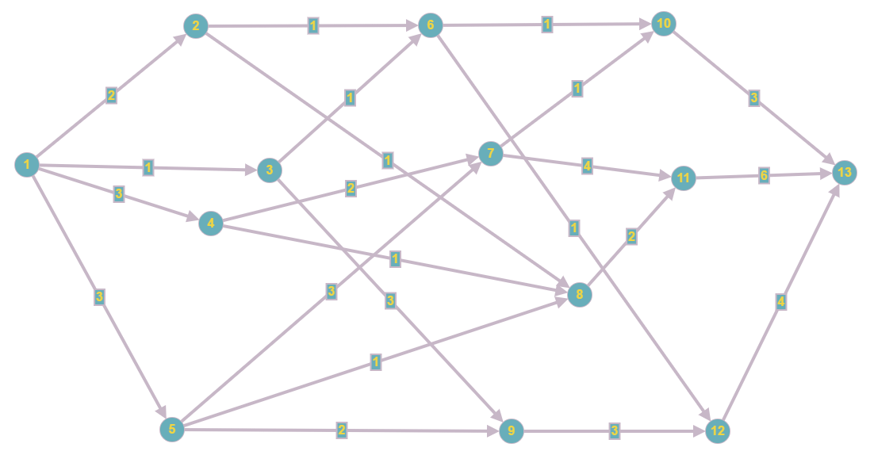

|  |  |  |  |  |  |  |  |  |  |  |  |  |  |
| --- | --- | --- | --- | --- | --- | --- | --- | --- | --- | --- | --- | --- | --- |
|  | X1 | X2 | X3 | X4 | X5 | X6 | X7 | X8 | X9 | X10 | X11 | X12 | X13 |
| X1 | 0 | 2 | 1 | 3 | 3 | ∞ | ∞ | ∞ | ∞ | ∞ | ∞ | ∞ | ∞ |
| X2 | ∞ | 0 | ∞ | ∞ | ∞ | 1 | ∞ | 1 | ∞ | ∞ | ∞ | ∞ | ∞ |
| X3 | ∞ | ∞ | 0 | ∞ | ∞ | 1 | ∞ | ∞ | 3 | ∞ | ∞ | ∞ | ∞ |
| X4 | ∞ | ∞ | ∞ | 0 | ∞ | ∞ | 2 | 1 | ∞ | ∞ | ∞ | ∞ | ∞ |
| X5 | ∞ | ∞ | ∞ | ∞ | 0 | ∞ | 3 | 1 | 2 | ∞ | ∞ | ∞ | ∞ |
| X6 | ∞ | ∞ | ∞ | ∞ | ∞ | 0 | ∞ | ∞ | ∞ | 1 | ∞ | 1 | ∞ |
| X7 | ∞ | ∞ | ∞ | ∞ | ∞ | ∞ | 0 | ∞ | ∞ | 1 | 4 | ∞ | ∞ |
| X8 | ∞ | ∞ | ∞ | ∞ | ∞ | ∞ | ∞ | 0 | ∞ | ∞ | 2 | ∞ | ∞ |
| X9 | ∞ | ∞ | ∞ | ∞ | ∞ | ∞ | ∞ | ∞ | 0 | ∞ | ∞ | 3 | ∞ |
| X10 | ∞ | ∞ | ∞ | ∞ | ∞ | ∞ | ∞ | ∞ | ∞ | 0 | ∞ | ∞ | 3 |
| X11 | ∞ | ∞ | ∞ | ∞ | ∞ | ∞ | ∞ | ∞ | ∞ | ∞ | 0 | ∞ | 6 |
| X12 | ∞ | ∞ | ∞ | ∞ | ∞ | ∞ | ∞ | ∞ | ∞ | ∞ | ∞ | 0 | 4 |
| X13 | ∞ | ∞ | ∞ | ∞ | ∞ | ∞ | ∞ | ∞ | ∞ | ∞ | ∞ | ∞ | 0 |

Матрица расстояний:

Алгоритм Дейкстры:

y = x1;

d(x2) = min{d(x2),d(y) + a(y; x2)} = min{} = 2;

d(x3) = min{d(x3), d(y)+a(y; x3)} = min{; 0 + 1} = 1;

d(x4) = min{d(x4), d(y)+a(y; x4)} = min{; 0 + 3} = 3;

d(x5) = min{d(x5), d(y)+a(y;x5)} = min{; 0 + 3} = 3;

y = x3;

C:\Users\Владимир\Downloads\1.png

d(x6) = min{d(x6), d(y)+a(y; x6)} = min{; 1 + 1} = 2;

d(x9) = min{d(x9), d(y)+a(y; x9)} = min{; 1 + 3} = 4;

d(x2) = 2;

d(x4) = 3;

d(x5) = 3;

y = x2;

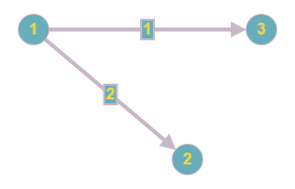

d(x6) = min{d(x6), d(y)+a(y; x6)} = min{2; 2 + 1} = 2;

d(x8) = min{d(x8), d(y)+a(y; x8)} = min{; 2 + 1 } = 3;

d(x9) = 4;

d(x4) = 3;

d(x5) = 3;

y = x6;

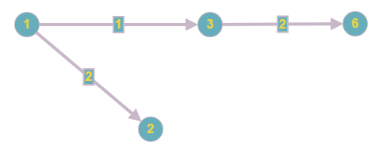

d(x10) = min{d(x10), d(y)+a(y; x10)} = min{; 2 + 1} = 3;

d(x12) = min{d(x12), d(y)+a(y; x12)} = min{; 2 + 1} = 3;

d(x8) = 3;

d(x9) = 4;

d(x4) = 3;

d(x5) = 3;

y = x4;

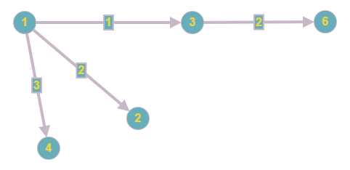

d(x7) = min{d(x7), d(y)+a(y; x7)} = min{; 3 + 2} = 5;

d(x8) = min{d(x8), d(y)+a(y; x8)} = min{3; 3 + 1} = 3 ;

d(x10) = 3;

d(x12) = 3;

d(x9) = 4;

d(x5) = 3;

y = x5;

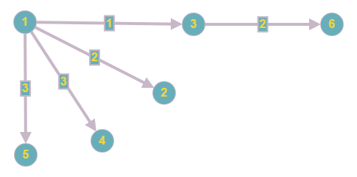

d(x7) = min{d(x7), d(y)+a(y; x7)} = min{5; 3 + 3} = 5;

d(x8) = min{d(x8), d(y)+a(y; x8)} = min{3; 3 + 1} = 3;

d(x9) = min{d(x9), d(y)+a(y; x9)} = min{4; 3 + 2} = 4;

d(x10) = 3;

d(x12) = 3;

y = x8;

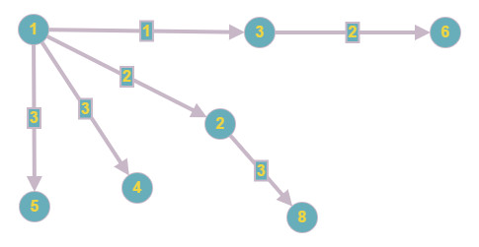

d(x10) = min{d(x10), d(y)+a(y; x10)} = min{3; 3 + 2} = 3;

d(x7) = 5;

d(x9) = 4;

d(x12) = 3;

y = x10;

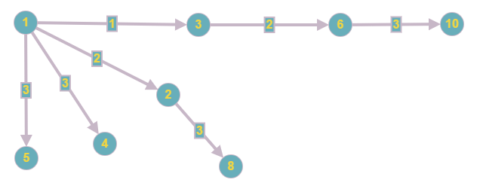

d(x13) = min{d(x13), d(y)+a(y; x13)} = min{; 3 + 3} = 6;

d(x7) = 5;

d(x9) = 4;

d(x12) = 3;

y = x12;

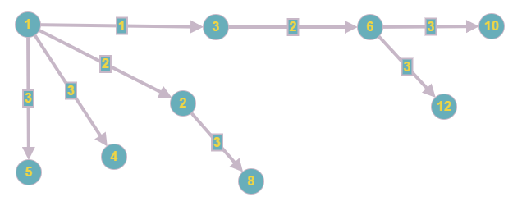

d(x13) = min{d(x13), d(y)+a(y; x13)} = min{6; 3 + 4} = 6;

d(x7) = 5;

d(x9) = 4;

y = x9;

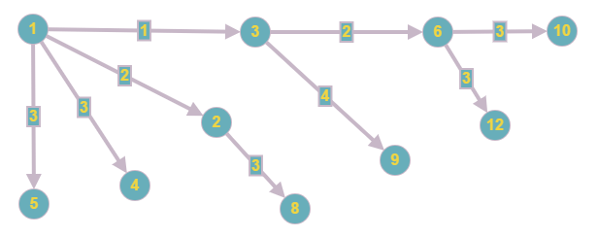

d(x7) = 5;

d(x13) = 6;

y = x7;

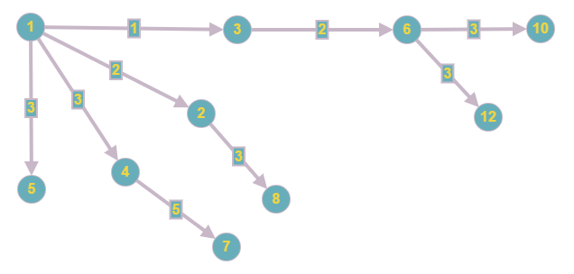

d(x11) = min{d(x11), d(y)+a(y; x11)} = min{; 5 + 4} = 9;

y = x11;

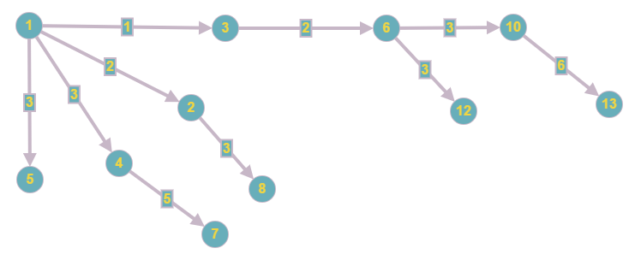

d(x13) = min{d(x13), d(y)+a(y; x13)} = min{6; 9 + 6} = 6;

**Кратчайшее расстояние между x1 и x13 = 6.**

Алгоритм Данцига:

D0 =

|  |  |  |  |  |  |  |  |  |  |  |  |  |  |
| --- | --- | --- | --- | --- | --- | --- | --- | --- | --- | --- | --- | --- | --- |
|  | X1 | X2 | X3 | X4 | X5 | X6 | X7 | X8 | X9 | X10 | X11 | X12 | X13 |
| X1 | 0 | 2 | 1 | 3 | 3 | ∞ | ∞ | ∞ | ∞ | ∞ | ∞ | ∞ | ∞ |
| X2 | ∞ | 0 | ∞ | ∞ | ∞ | 1 | ∞ | 1 | ∞ | ∞ | ∞ | ∞ | ∞ |
| X3 | ∞ | ∞ | 0 | ∞ | ∞ | ∞ | ∞ | ∞ | 3 | ∞ | ∞ | ∞ | ∞ |
| X4 | ∞ | ∞ | ∞ | 0 | ∞ | ∞ | 2 | 1 | ∞ | ∞ | ∞ | ∞ | ∞ |
| X5 | ∞ | ∞ | ∞ | ∞ | 0 | ∞ | 3 | 1 | 2 | ∞ | ∞ | ∞ | ∞ |
| X6 | ∞ | ∞ | ∞ | ∞ | ∞ | 0 | ∞ | ∞ | ∞ | 1 | ∞ | 1 | ∞ |
| X7 | ∞ | ∞ | ∞ | ∞ | ∞ | ∞ | 0 | ∞ | ∞ | 1 | 4 | ∞ | ∞ |
| X8 | ∞ | ∞ | ∞ | ∞ | ∞ | ∞ | ∞ | 0 | ∞ | ∞ | 2 | ∞ | ∞ |
| X9 | ∞ | ∞ | ∞ | ∞ | ∞ | ∞ | ∞ | ∞ | 0 | ∞ | ∞ | 3 | ∞ |
| X10 | ∞ | ∞ | ∞ | ∞ | ∞ | ∞ | ∞ | ∞ | ∞ | 0 | ∞ | ∞ | 3 |
| X11 | ∞ | ∞ | ∞ | ∞ | ∞ | ∞ | ∞ | ∞ | ∞ | ∞ | 0 | ∞ | 6 |
| X12 | ∞ | ∞ | ∞ | ∞ | ∞ | ∞ | ∞ | ∞ | ∞ | ∞ | ∞ | 0 | 4 |
| X13 | ∞ | ∞ | ∞ | ∞ | ∞ | ∞ | ∞ | ∞ | ∞ | ∞ | ∞ | ∞ | 0 |

D1 = (d111) = (0)

|  |  |
| --- | --- |
|  | x1 |
| x1 | 0 |

|  |  |
| --- | --- |
|  | x1 |
| x1 | - |

D2

d2,12 = min{∞ + 0} = ∞

d1,22 = min{0 + 2} = 2

|  |  |  |
| --- | --- | --- |
|  | x1 | x2 |
| x1 | 0 | 2 |
| x2 | ∞ | 0 |

|  |  |  |
| --- | --- | --- |
|  | x1 | x2 |
| x1 | - | (1;2) |
| x2 | - | - |

D3

d3,13 = min{∞ + 0,∞ + ∞} = ∞

d3,23 = min{∞ + 2,∞ + 0} = ∞

d1,33 = min{0 + 1, 2 + ∞} = 1

d2,33 = min{∞ + 1,0 + ∞} = ∞

d1,23 = min{2 + ∞,2} = 2

d2,13 = min{∞ + ∞,∞} = ∞

|  |  |  |  |
| --- | --- | --- | --- |
|  | x1 | x2 | x3 |
| x1 | 0 | 2 | 1 |
| x2 | ∞ | 0 | ∞ |
| x3 | ∞ | ∞ | 0 |

|  |  |  |  |
| --- | --- | --- | --- |
|  | x1 | x2 | x3 |
| x1 | - | (1;2) | (1;3) |
| x2 | - | - | - |
| x3 | - | - | - |

D4

d4,14 = min{∞ + 0,∞ + ∞,∞ + ∞} = ∞

d4,24 = min{∞ + 2,∞ + 0,∞ + ∞} = ∞

d4,34 = min{∞ + 1,∞ + ∞,∞ + 0} = ∞

d1,44 = min{0 + 3, 2 + ∞,1+ ∞} = 3

d2,44 = min{∞ + 3,0 + ∞,∞ + ∞} = ∞

d3,44 = min{∞ + 3,∞ + ∞,0 + ∞} = ∞

d1,24 = min{3 + ∞,2} = 2

d1,34 = min{3+ ∞,1} = 1

d2,14 = min{∞ + ∞,∞} = ∞

d2,34 = min{∞ + ∞,∞} = ∞

d3,14 = min{∞ + ∞,∞} = ∞

d3,24 = min{∞ + ∞,∞} = ∞

|  |  |  |  |  |
| --- | --- | --- | --- | --- |
|  | x1 | x2 | x3 | x4 |
| x1 | 0 | 2 | 1 | 3 |
| x2 | ∞ | 0 | ∞ | ∞ |
| x3 | ∞ | ∞ | 0 | ∞ |
| x4 | ∞ | ∞ | ∞ | 0 |

|  |  |  |  |  |
| --- | --- | --- | --- | --- |
|  | x1 | x2 | x3 | x4 |
| x1 | - | (1;2) | (1;3) | (1;4) |
| x2 | - | - | - | - |
| x3 | - | - | - | - |
| x4 | - | - | - | - |

D5

d5,15 = min{∞ + 0,∞ + ∞,∞ + ∞,∞ + ∞} = ∞

d5,25 = min{∞ + 2,∞ + 0,∞ + ∞,∞ + ∞} = ∞

d5,35 = min{∞ + 1,∞ + ∞,∞ + 0,∞ + ∞} = ∞

d5,45 = min{∞ + 3,∞ + ∞,∞ + ∞,∞ + 0} = ∞

d1,55 = min{0 + 3,2 + ∞,1 +∞,3 + ∞} = 3

d2,55 = min{∞ +3,0 + ∞,∞ + ∞,∞ + ∞} = ∞

d3,55 = min{∞ + 3,∞ + ∞,0 + ∞,∞ + ∞} = ∞

d4,55 = min{∞ + 3,∞ + ∞,∞ + ∞,0 + ∞} = ∞

d1,25 = min{3 + ∞,2} = 2

d1,35 = min{3 + ∞,1} = 1

d1,45 = min{3 + ∞,3} = 3

d2,15 = min{∞ + ∞,∞} = ∞

d2,35 = min{∞ + ∞,∞} = ∞

d2,45 = min{∞ + ∞,∞} = ∞

d3,15 = min{∞ + ∞,∞} = ∞

d3,25 = min{∞ + ∞,∞} = ∞

d3,45 = min{∞ + ∞,∞} = ∞

d4,15 = min{∞ + ∞,∞} = ∞

d4,25 = min{∞ + ∞,∞} = ∞

d4,35 = min{∞ + ∞,∞} = ∞

|  |  |  |  |  |  |
| --- | --- | --- | --- | --- | --- |
|  | x1 | x2 | x3 | x4 | x5 |
| x1 | 0 | 2 | 1 | 3 | 3 |
| x2 | ∞ | 0 | ∞ | ∞ | ∞ |
| x3 | ∞ | ∞ | 0 | ∞ | ∞ |
| x4 | ∞ | ∞ | ∞ | 0 | ∞ |
| x5 | ∞ | ∞ | ∞ | ∞ | 0 |

|  |  |  |  |  |  |
| --- | --- | --- | --- | --- | --- |
|  | x1 | x2 | x3 | x4 | x5 |
| x1 | - | (1;2) | (1;3) | (1;4) | (1;5) |
| x2 | - | - | - | - | - |
| x3 | - | - | - | - | - |
| x4 | - | - | - | - | - |
| x5 | - | - | - | - | - |

D6

d6,16 = min{∞ + 0,∞ + ∞,∞ + ∞,∞ + ∞,∞ + ∞} = ∞

d6,26 = min{∞ + 3,∞ + 0,∞ + ∞,∞ + ∞,∞ + ∞} = ∞

d6,36 = min{∞ + 1,∞ + ∞,∞ + 0,∞ + ∞,∞ + ∞} = ∞

d6,46 = min{∞ + 3,∞ + ∞,∞ + ∞,∞ + 0,∞ + ∞} = ∞

d6,56 = min{∞ + 3,∞ + ∞,∞ + ∞,∞ + ∞,∞ + 0} = ∞

d1,66 = min{0 + ∞,2 + 1,1 + 1,3 + ∞,3 + ∞} = 2

d2,66 = min{∞ + ∞,0 + 1,∞ , ∞, ∞} = 1

d3,66 = min{∞ + ∞,∞ + 1,0 + 1,∞ + ∞,∞ + ∞} = 1

d4,66 = min{∞ + ∞,∞ + 1,∞ + 1,0 + ∞,∞ + ∞} = ∞

d5,66 = min{∞ + ∞,∞ + 1,∞ + 1,∞ + ∞,0 + ∞} = ∞

d1,26 = min{∞ + ∞,2} = 2

d1,36 = min{∞ + ∞,1} = 1

d1,46 = min{∞ + ∞,3} = 3

d1,56 = min{∞ + ∞,3} = 3

d2,16 = min{∞ + ∞,∞} = ∞

d2,36 = min{∞ + ∞,∞} = ∞

d2,46 = min{∞ + ∞,∞} = ∞

d2,56 = min{∞ + ∞,∞} = ∞

d3,16 = min{1 + ∞,∞} = ∞

d3,26 = min{1 + ∞,∞} = ∞

d3,46 = min{1 + ∞,∞} = ∞

d3,56 = min{1 + ∞,∞} = ∞

d4,16 = min{∞ + ∞,∞} = ∞

d4,26 = min{∞ + ∞,∞} = ∞

d4,36 = min{∞ + ∞,∞} = ∞

d4,56 = min{∞ + ∞,∞} = ∞

d5,16 = min{∞ + ∞,∞} = ∞

d5,26 = min{∞ + ∞,∞} = ∞

d5,36 = min{∞ + ∞,∞} = ∞

d5,46 = min{∞ + ∞,∞} = ∞

|  |  |  |  |  |  |  |
| --- | --- | --- | --- | --- | --- | --- |
|  | x1 | x2 | x3 | x4 | x5 | x6 |
| x1 | 0 | 2 | 1 | 3 | 3 | 2 |
| x2 | ∞ | 0 | ∞ | ∞ | ∞ | 1 |
| x3 | ∞ | ∞ | 0 | ∞ | ∞ | 1 |
| x4 | ∞ | ∞ | ∞ | 0 | ∞ | ∞ |
| x5 | ∞ | ∞ | ∞ | ∞ | 0 | ∞ |
| x6 | ∞ | ∞ | ∞ | ∞ | ∞ | 0 |

|  |  |  |  |  |  |  |
| --- | --- | --- | --- | --- | --- | --- |
|  | x1 | x2 | x3 | x4 | x5 | x6 |
| x1 | - | (1;2) | (1;3) | (1;4) | (1;5) | (1;3) (3;6) |
| x2 | - | - | - | - | - | (2;6) |
| x3 | - | - | - | - | - | (3;6) |
| x4 | - | - | - | - | - | - |
| x5 | - | - | - | - | - | - |
| x6 | - | - | - | - | - | - |

D7

|  |  |  |  |  |  |  |  |
| --- | --- | --- | --- | --- | --- | --- | --- |
|  | x1 | x2 | x3 | x4 | x5 | x6 | x7 |
| x1 | 0 | 2 | 1 | 3 | 3 | 2 | 5 |
| x2 | ∞ | 0 | ∞ | ∞ | ∞ | 1 | ∞ |
| x3 | ∞ | ∞ | 0 | ∞ | ∞ | 1 | ∞ |
| x4 | ∞ | ∞ | ∞ | 0 | ∞ | ∞ | ∞ |
| x5 | ∞ | ∞ | ∞ | ∞ | 0 | ∞ | 3 |
| x6 | ∞ | ∞ | ∞ | ∞ | ∞ | 0 | ∞ |
| x7 | ∞ | ∞ | ∞ | ∞ | ∞ | ∞ | 0 |

|  |  |  |  |  |  |  |  |
| --- | --- | --- | --- | --- | --- | --- | --- |
|  | x1 | x2 | x3 | x4 | x5 | x6 | x7 |
| x1 | - | (1;2) | (1;3) | (1;4) | (1;5) | (1;3) (3;6) | (1;4) (4;7) |
| x2 | - | - | - | - | - | (2;6) | - |
| x3 | - | - | - | - | (- | (3;6) | - |
| x4 | - | - | - | - | - | - | - |
| x5 | - | - | - | - | - | - | (5;7) |
| x6 | - | - | - | - | - | - | - |
| x7 | - | - | - | - | - | - | - |

D8

|  |  |  |  |  |  |  |  |  |
| --- | --- | --- | --- | --- | --- | --- | --- | --- |
|  | x1 | x2 | x3 | x4 | x5 | x6 | x7 | x8 |
| x1 | 0 | 2 | 1 | 3 | 3 | 2 | 5 | 4 |
| x2 | ∞ | 0 | ∞ | ∞ | ∞ | 1 | ∞ | 1 |
| x3 | ∞ | ∞ | 0 | ∞ | ∞ | 1 | ∞ | ∞ |
| x4 | ∞ | ∞ | ∞ | 0 | ∞ | ∞ | ∞ | 1 |
| x5 | ∞ | ∞ | ∞ | ∞ | 0 | ∞ | 3 | 1 |
| x6 | ∞ | ∞ | ∞ | ∞ | ∞ | 0 | ∞ | ∞ |
| x7 | ∞ | ∞ | ∞ | ∞ | ∞ | ∞ | 0 | ∞ |
| x8 | ∞ | ∞ | ∞ | ∞ | ∞ | ∞ | ∞ | 0 |

|  |  |  |  |  |  |  |  |  |
| --- | --- | --- | --- | --- | --- | --- | --- | --- |
|  | x1 | x2 | x3 | x4 | x5 | x6 | x7 | x8 |
| x1 | - | (1;2) | (1;3) | (1;4) | (1;5) | (1;3) (3;6) | (1;4) (4;7) | (1;4) (4;8) |
| x2 | - | - | - | - | - | (2;6) | - | (2;8) |
| x3 | - | - | - | - | - | (3;6) | - |  |
| x4 | - | - | - | - | - | - | - | (4;8) |
| x5 | - | - | - | - | - | - | (5;7) | (5;8) |
| x6 | - | - | - | - | - | - | - | - |
| x7 | - | - | - | - | - | - | - | - |
| x8 | - | - | - | - | - | - | - | - |

D9

|  |  |  |  |  |  |  |  |  |  |
| --- | --- | --- | --- | --- | --- | --- | --- | --- | --- |
|  | x1 | x2 | x3 | x4 | x5 | x6 | x7 | x8 | x9 |
| x1 | 0 | 2 | 1 | 3 | 3 | 2 | 5 | 4 | 4 |
| x2 | ∞ | 0 | ∞ | ∞ | ∞ | 1 | ∞ | 1 | ∞ |
| x3 | ∞ | ∞ | 0 | ∞ | ∞ | 1 | ∞ | ∞ | 3 |
| x4 | ∞ | ∞ | ∞ | 0 | ∞ | ∞ | ∞ | 1 | ∞ |
| x5 | ∞ | ∞ | ∞ | ∞ | 0 | ∞ | 3 | 1 | 2 |
| x6 | ∞ | ∞ | ∞ | ∞ | ∞ | 0 | ∞ | ∞ | ∞ |
| x7 | ∞ | ∞ | ∞ | ∞ | ∞ | ∞ | 0 | ∞ | ∞ |
| x8 | ∞ | ∞ | ∞ | ∞ | ∞ | ∞ | ∞ | 0 | ∞ |
| x9 | ∞ | ∞ | ∞ | ∞ | ∞ | ∞ | ∞ | ∞ | 0 |

|  |  |  |  |  |  |  |  |  |  |
| --- | --- | --- | --- | --- | --- | --- | --- | --- | --- |
|  | x1 | x2 | x3 | x4 | x5 | x6 | x7 | x8 | x9 |
| x1 | - | (1;2) | (1;3) | (1;4) | (1;5) | (1;3) (3;6) | (1;4) (4;7) | (1;4) (4;8) | (1;3) (3;9) |
| x2 | - | - | - | - | - | (2;6) | - | (2;8) |  |
| x3 | - | - | - | - | - | (3;6) | - | - | (3;9) |
| x4 | - | - | - | - | - | - | - | (4;8) | - |
| x5 | - | - | - | - | - | - | (5;7) | (5;8) | (5;9) |
| x6 | - | - | - | - | - | - | - | - | - |
| x7 | - | - | - | - | - | - | - | - | - |
| x8 | - | - | - | - | - | - | - | - | - |
| x9 | - | - | - | - | - | - | - | - | - |

D10

|  |  |  |  |  |  |  |  |  |  |  |
| --- | --- | --- | --- | --- | --- | --- | --- | --- | --- | --- |
|  | x1 | x2 | x3 | x4 | x5 | x6 | x7 | x8 | x9 | x10 |
| x1 | 0 | 2 | 1 | 3 | 3 | 2 | 5 | 4 | 4 | 3 |
| x2 | ∞ | 0 | ∞ | ∞ | ∞ | 1 | ∞ | 1 | ∞ | 2 |
| x3 | ∞ | ∞ | 0 | ∞ | ∞ | 1 | ∞ | ∞ | 3 | 2 |
| x4 | ∞ | ∞ | ∞ | 0 | ∞ | ∞ | ∞ | 1 | ∞ | ∞ |
| x5 | ∞ | ∞ | ∞ | ∞ | 0 | ∞ | 3 | 1 | 2 | 4 |
| x6 | ∞ | ∞ | ∞ | ∞ | ∞ | 0 | ∞ | ∞ | ∞ | 1 |
| x7 | ∞ | ∞ | ∞ | ∞ | ∞ | ∞ | 0 | ∞ | ∞ | 1 |
| x8 | ∞ | ∞ | ∞ | ∞ | ∞ | ∞ | ∞ | 0 | ∞ | ∞ |
| x9 | ∞ | ∞ | ∞ | ∞ | ∞ | ∞ | ∞ | ∞ | 0 | ∞ |
| x10 | ∞ | ∞ | ∞ | ∞ | ∞ | ∞ | ∞ | ∞ | ∞ | 0 |

|  |  |  |  |  |  |  |  |  |  |  |
| --- | --- | --- | --- | --- | --- | --- | --- | --- | --- | --- |
|  | x1 | x2 | x3 | x4 | x5 | x6 | x7 | x8 | x9 | x10 |
| x1 | - | (1;2) | (1;3) | (1;4) | (1;5) | (1;3) (3;6) | (1;4) (4;7) | (1;4) (4;8) | (1;3) (3;9) | (1;3) (3;6) (6;10) |
| x2 | - | - | - | - | - | (2;6) | - | (2;8) | - | (2;6) (6;10) |
| x3 | - | - | - | - | - | (3;6) | (3;7) | - | (3;9) | (3;6) (6;10) |
| x4 | - | - | - | - | - | - | - | (4;8) | - | - |
| x5 | - | - | - | - | - | - | (5;7) | (5;8) | (5;9) | (5;7) (7;10) |
| x6 | - | - | - | - | - | - | - | - | - | (6;10) |
| x7 | - | - | - | - | - | - | - | - | - | (7;10) |
| x8 | - | - | - | - | - | - | - | - | - | - |
| x9 | - | - | - | - | - | - | - | - | - | - |
| x10 | - | - | - | - | - | - | - | - | - | - |

D11

|  |  |  |  |  |  |  |  |  |  |  |  |
| --- | --- | --- | --- | --- | --- | --- | --- | --- | --- | --- | --- |
|  | x1 | x2 | x3 | x4 | x5 | x6 | x7 | x8 | x9 | x10 | x11 |
| x1 | 0 | 2 | 1 | 3 | 3 | 2 | 5 | 4 | 4 | 3 | 6 |
| x2 | ∞ | 0 | ∞ | ∞ | ∞ | 1 | ∞ | 1 | ∞ | 2 | 3 |
| x3 | ∞ | ∞ | 0 | ∞ | ∞ | 1 | ∞ | ∞ | 3 | 2 | ∞ |
| x4 | ∞ | ∞ | ∞ | 0 | ∞ | ∞ | ∞ | 1 | ∞ | ∞ | 3 |
| x5 | ∞ | ∞ | ∞ | ∞ | 0 | ∞ | 3 | 1 | 2 | 4 | 3 |
| x6 | ∞ | ∞ | ∞ | ∞ | ∞ | 0 | ∞ | ∞ | ∞ | 1 | ∞ |
| x7 | ∞ | ∞ | ∞ | ∞ | ∞ | ∞ | 0 | ∞ | ∞ | 1 | 4 |
| x8 | ∞ | ∞ | ∞ | ∞ | ∞ | ∞ | ∞ | 0 | ∞ | ∞ | 2 |
| x9 | ∞ | ∞ | ∞ | ∞ | ∞ | ∞ | ∞ | ∞ | 0 | ∞ | ∞ |
| x10 | ∞ | ∞ | ∞ | ∞ | ∞ | ∞ | ∞ | ∞ | ∞ | 0 | ∞ |
| x11 | ∞ | ∞ | ∞ | ∞ | ∞ | ∞ | ∞ | ∞ | ∞ | ∞ | 0 |

|  |  |  |  |  |  |  |  |  |  |  |  |
| --- | --- | --- | --- | --- | --- | --- | --- | --- | --- | --- | --- |
|  | x1 | x2 | x3 | x4 | x5 | x6 | x7 | x8 | x9 | x10 | x11 |
| x1 | - | (1;2) | (1;3) | (1;4) | (1;5) | (1;3) (3;6) | (1;4) (4;7) | (1;4) (4;8) | (1;3) (3;9) | (1;3) (3;6) (6;10) | (1;5) (5;8) (8;11) |
| x2 | - | - | - | - | - | (2;6) | - | (2;8) | - | (2;6) (6;10) | (2;8) (8;11) |
| x3 | - | - | - | - | - | (3;6) | (3;7) | - | (3;9) | (3;6) (6;10) | - |
| x4 | - | - | - | - | - | - | - | (4;8) | - | - | (4;8) (8;11) |
| x5 | - | - | - | - | - | - | (5;7) | (5;8) | (5;9) | (5;7) (7;10) | (5;8) (8;11) |
| x6 | - | - | - | - | - | - | - | - | - | (6;10) | - |
| x7 | - | - | - | - | - | - | - | - | - | (7;10) | (7;11) |
| x8 | - | - | - | - | - | - | - | - | - | - | (8;11) |
| x9 | - | - | - | - | - | - | - | - | - | - | - |
| x10 | - | - | - | - | - | - | - | - | - | - | - |
| x11 | - | - | - | - | - | - | - | - | - | - | - |

D12

|  |  |  |  |  |  |  |  |  |  |  |  |  |
| --- | --- | --- | --- | --- | --- | --- | --- | --- | --- | --- | --- | --- |
|  | x1 | x2 | x3 | x4 | x5 | x6 | x7 | x8 | x9 | x10 | x11 | x12 |
| x1 | 0 | 2 | 1 | 3 | 3 | 2 | 5 | 4 | 4 | 3 | 6 | 3 |
| x2 | ∞ | 0 | ∞ | ∞ | ∞ | 1 | ∞ | 1 | ∞ | 2 | 3 | 2 |
| x3 | ∞ | ∞ | 0 | ∞ | ∞ | 1 | ∞ | ∞ | 3 | 2 | ∞ | 2 |
| x4 | ∞ | ∞ | ∞ | 0 | ∞ | ∞ | ∞ | 1 | ∞ | ∞ | 3 | ∞ |
| x5 | ∞ | ∞ | ∞ | ∞ | 0 | ∞ | 3 | 1 | 2 | 4 | 3 | 5 |
| x6 | ∞ | ∞ | ∞ | ∞ | ∞ | 0 | ∞ | ∞ | ∞ | 1 | ∞ | 1 |
| x7 | ∞ | ∞ | ∞ | ∞ | ∞ | ∞ | 0 | ∞ | ∞ | 1 | 4 | ∞ |
| x8 | ∞ | ∞ | ∞ | ∞ | ∞ | ∞ | ∞ | 0 | ∞ | ∞ | 2 | ∞ |
| x9 | ∞ | ∞ | ∞ | ∞ | ∞ | ∞ | ∞ | ∞ | 0 | ∞ | ∞ | 3 |
| x10 | ∞ | ∞ | ∞ | ∞ | ∞ | ∞ | ∞ | ∞ | ∞ | 0 | ∞ | ∞ |
| x11 | ∞ | ∞ | ∞ | ∞ | ∞ | ∞ | ∞ | ∞ | ∞ | ∞ | 0 | ∞ |
| x12 | ∞ | ∞ | ∞ | ∞ | ∞ | ∞ | ∞ | ∞ | ∞ | ∞ | ∞ | 0 |

|  |  |  |  |  |  |  |  |  |  |  |  |  |
| --- | --- | --- | --- | --- | --- | --- | --- | --- | --- | --- | --- | --- |
|  | x1 | x2 | x3 | x4 | x5 | x6 | x7 | x8 | x9 | x10 | x11 | x12 |
| x1 | - | (1;2) | (1;3) | (1;2) (2;4) | (1;2) (2;5) | (1;3) (3;6) | (1;4) (4;7) | (1;4) (4;8) | (1;3) (3;9) | (1;3) (3;6) (6;10) | (1;5) (5;8) (8;11) | (1;3) (3;6) (6;12) |
| x2 | - | - | - | - | - | (2;6) | - | (2;8) | - | (2;6)  (6;10) | (2;8) (8;11) | (2;6) (6;12) |
| x3 | - | - | - | - | - | (3;6) | (3;7) | - | (3;9) | (3;6) (6;10) | - | (3;6) (6;12) |
| x4 | - | - | - | - | - | - | - | (4;8) | - | - | (4;8)  (8;11) | - |
| x5 | - | - | - | - | - | - | (5;7) | (5;8) | (5;9) | (5;7)  (7;10) | (5;8) (8;11) | (5;9) (9;12) |
| x6 | - | - | - | - | - | - | - | - | - | (6;10) | - | (6;12) |
| x7 | - | - | - | - | - | - | - | - | - | (7;10) | (7;11) | - |
| x8 | - | - | - | - | - | - | - | - | - | - | (8;11) | - |
| x9 | - | - | - | - | - | - | - | - | - | - | - | (9;12) |
| x10 | - | - | - | - | - | - | - | - | - | - | - | - |
| x11 | - | - | - | - | - | - | - | - | - | - | - | - |
| x12 | - | - | - | - | - | - | - | - | - | - | - | - |

D13

|  |  |  |  |  |  |  |  |  |  |  |  |  |  |
| --- | --- | --- | --- | --- | --- | --- | --- | --- | --- | --- | --- | --- | --- |
|  | x1 | x2 | x3 | x4 | x5 | x6 | x7 | x8 | x9 | x10 | x11 | x12 | x13 |
| x1 | 0 | 2 | 1 | 3 | 3 | 2 | 5 | 4 | 4 | 3 | 6 | 3 | 6 |
| x2 | ∞ | 0 | ∞ | ∞ | ∞ | 1 | ∞ | 1 | ∞ | 2 | 3 | 2 | 5 |
| x3 | ∞ | ∞ | 0 | ∞ | ∞ | 1 | ∞ | ∞ | 3 | 2 | ∞ | 2 | 5 |
| x4 | ∞ | ∞ | ∞ | 0 | ∞ | ∞ | ∞ | 1 | ∞ | ∞ | 3 | ∞ | 9 |
| x5 | ∞ | ∞ | ∞ | ∞ | 0 | ∞ | 3 | 1 | 2 | 4 | 3 | 5 | 7 |
| x6 | ∞ | ∞ | ∞ | ∞ | ∞ | 0 | ∞ | ∞ | ∞ | 1 | ∞ | 1 | 4 |
| x7 | ∞ | ∞ | ∞ | ∞ | ∞ | ∞ | 0 | ∞ | ∞ | 1 | 4 | ∞ | 4 |
| x8 | ∞ | ∞ | ∞ | ∞ | ∞ | ∞ | ∞ | 0 | ∞ | ∞ | 2 | ∞ | 8 |
| x9 | ∞ | ∞ | ∞ | ∞ | ∞ | ∞ | ∞ | ∞ | 0 | ∞ | ∞ | 3 | 7 |
| x10 | ∞ | ∞ | ∞ | ∞ | ∞ | ∞ | ∞ | ∞ | ∞ | 0 | ∞ | ∞ | 3 |
| x11 | ∞ | ∞ | ∞ | ∞ | ∞ | ∞ | ∞ | ∞ | ∞ | ∞ | 0 | ∞ | 6 |
| x12 | ∞ | ∞ | ∞ | ∞ | ∞ | ∞ | ∞ | ∞ | ∞ | ∞ | ∞ | 0 | 4 |
| x13 | ∞ | ∞ | ∞ | ∞ | ∞ | ∞ | ∞ | ∞ | ∞ | ∞ | ∞ | ∞ | 0 |

|  |  |  |  |  |  |  |  |  |  |  |  |  |  |
| --- | --- | --- | --- | --- | --- | --- | --- | --- | --- | --- | --- | --- | --- |
|  | x1 | x2 | x3 | x4 | x5 | x6 | x7 | x8 | x9 | x10 | x11 | x12 | x13 |
| x1 | - | (1;2) | (1;3) | (1;4) | (1;5) | (1;3) (3;6) | (1;4) (4;7) | (1;4) (4;8) | (1;3) (3;9) | (1;3) (3;6) (6;10) | (1;5) (5;8) (8;11) | (1;3) (3;6) (6;12) | (1;3) (3;6) (6;10) (10;13) |
| x2 | - | - | - | - | - | (2;6) | - | (2;8) | - | (2;6)  (6;10) | (2;8) (8;11) | (2;6) (6;12) | (2;6) (6;10) (10;13) |
| x3 | - | - | - | - | - | (3;6) | (3;7) | - | (3;9) | (3;6) (6;10) | - | (3;6) (6;12) | (3;6) (6;10) (10;13) |
| x4 | - | - | - | - | - | - | - | (4;8) | - | - | (4;8) (8;11) | - | (4;8) (8;11) (11;13) |
| x5 | - | - | - | - | - | - | (5;7) | (5;8) | (5;9) | (5;7) (7;10) | (5;8) (8;11) | (5;9) (9;12) | (5;7) (7;10) (10;13) |
| x6 | - | - | - | - | - | - | - | - | - | (6;10) | - | (6;12) | (6;10) (10;13) |
| x7 | - | - | - | - | - | - | - | - | - | (7;10) | (7;11) | - | (7;10) (10;13) |
| x8 | - | - | - | - | - | - | - | - | - | - | (8;11) | - | (8;11) (11;13) |
| x9 | - | - | - | - | - | - | - | - | - | - | - | (9;12) | (9;12) (12;13) |
| x10 | - | - | - | - | - | - | - | - | - | - | - | - | (10;13) |
| x11 | - | - | - | - | - | - | - | - | - | - | - | - | (11;13) |
| x12 | - | - | - | - | - | - | - | - | - | - | - | - | (12;13) |
| x13 | - | - | - | - | - | - | - | - | - | - | - | - | - |

**Минимальное расстояние от точки x1 до точки x13 равно 6**.

**Минимальный путь: (1;3)(3;6)(6;10)(10;13).**

Максимальный поток:

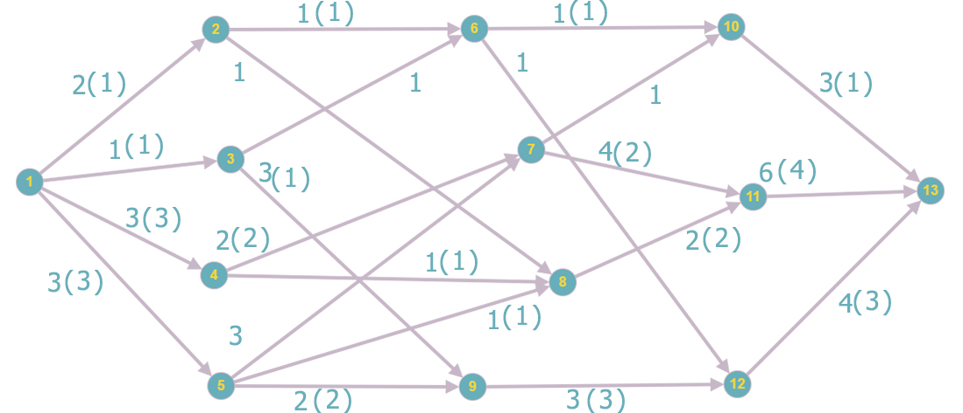

*Распределим дуги по множествам*

f(x1, x2) = 0 => (x1, x2) є I

f(x1, x3) = 0 => (x1, x3) є I

f(x1, x4) = 0 => (x1, x4) є I

f(x1, x5) = 0 => (x1, x5) є I

f(x2, x6) = 0 => (x2, x6) є I

f(x2, x8) = 0 => (x2, x8) є I

f(x3, x6) = 0 => (x3, x6) є I

f(x3, x9) = 0 => (x3, x9) є I

f(x4, x7) = 0 => (x4, x7) є I

f(x4, x8) = 0 => (x4, x8) є I

f(x5, x7) = 0 => (x5, x7) є I

f(x5, x8) = 0 => (x5, x8) є I

f(x5, x9) = 0 => (x5, x9) є I

f(x6, x10) = 0 => (x6, x10) є I

f(x6, x12) = 0 => (x6, x12) є I

f(x7, x10) = 0 => (x7, x10) є I

f(x7, x11) = 0 => (x7, x11) є I

f(x8, x11) = 0 => (x8, x11) є I

f(x9, x12) = 0 => (x9, x12) є I

f(x10, x13) = 0 => (x10, x13) є I

f(x11, x13) = 0 => (x11, x13) є I

f(x12, x13) = 0 => (x12, x13) є I

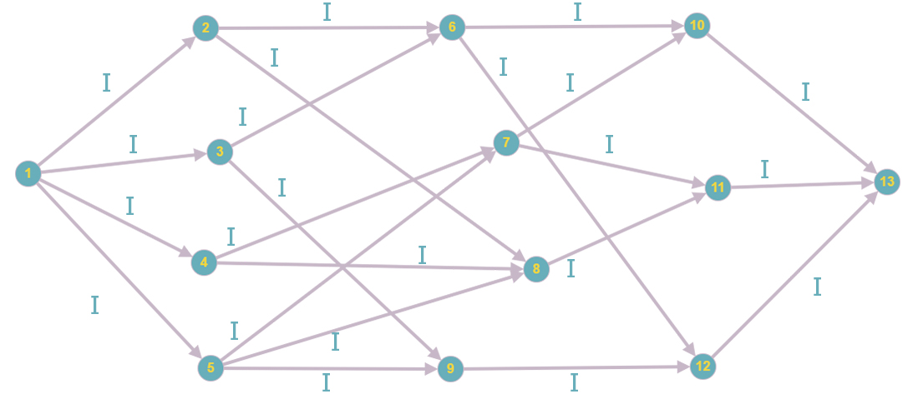

*Возьмем увеличивающий путь*

(x1, x2) (x2, x6) (x6, x10) (x10, x13)

*Найдем величину, на которую можно увеличить поток*

min {

i(x1, x2) = c(x1, x2) - f(x1, x2) = 2 - 0 = 12

i(x2, x6) = c(x2, x6) - f(x2, x6) = 1 - 0 = 1

i(x6, x10) = c(x6, x10) - f(x6, x10) = 1 - 0 = 1

i(x10, x13) = c(x10, x13) - f(x10, x13) = 3 - 0 = 3

} = 1

*Увеличим поток на данную величину*

f(x1, x2) = 0 + 1 = 1

f(x2, x6) = 0 + 1 = 1

f(x6, x10) = 0 + 1 = 1

f(x10, x13) = 0 + 1 = 1

*Распределим дуги по множествам*

f(x1, x2) = 1 ≠ c(x1, x2) =>(x1, x2) є I, R

f(x2, x6) = 1 = c(x2, x6) =>(x2, x6) є R

f(x6, x10) = 1 = c(x6, x10) =>(x6, x10) є R

f(x10, x13) = 1 ≠ c(x10, x13) =>(x10, x13) є I, R

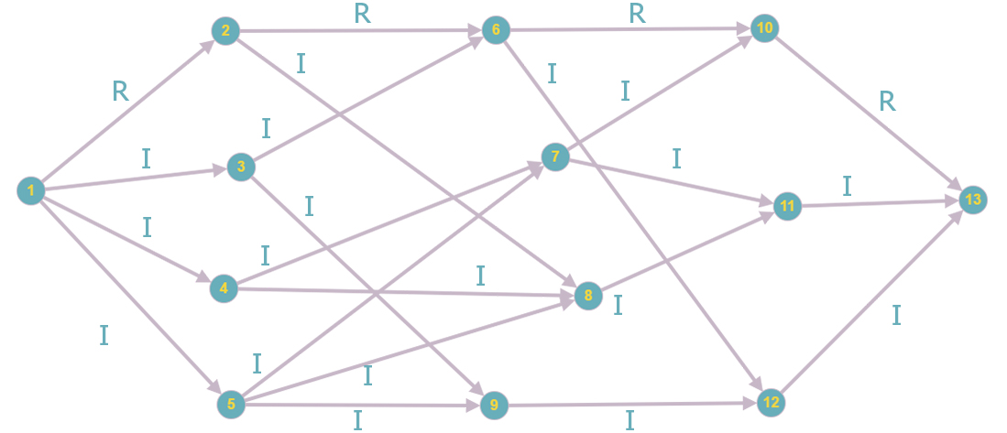

*Возьмем увеличивающий путь*

(x1, x4) (x4, x7) (x7, x10) (x10, x13)

*Найдем величину, на которую можно увеличить поток*

min {

i(x1, x4) = c(x1, x4) - f(x1, x4) = 3 - 0 = 3

i(x4, x7) = c(x4, x7) - f(x4, x7) = 2 - 0 = 2

i(x7, x10) = c(x7, x10) - f(x7, x10) = 1 - 0 = 1

i(x10, x13) = c(x10, x13) - f(x10, x13) = 3 - 1 = 2

} = 1

*Увеличим поток на данную величину*

f(x1, x4) = 0 + 1 = 1

f(x4, x7) = 0 + 1 = 1

f(x7, x10) = 0 + 1 = 1

f(x10, x13) = 1 + 1 = 2

*Распределим дуги по множествам*

f(x1, x4) = 1 ≠ c(x1, x4) = 3 => (x1, x4) є I,R

f(x4, x7) = 1 ≠ c(x4, x7) =>(x4, x7) є I, R

f(x7, x10) = 1 = c(x7, x10) =>(x7, x10) є R

f(x10, x13) = 2 ≠ c(x10, x13) = 3 => (x10, x13) є I,R

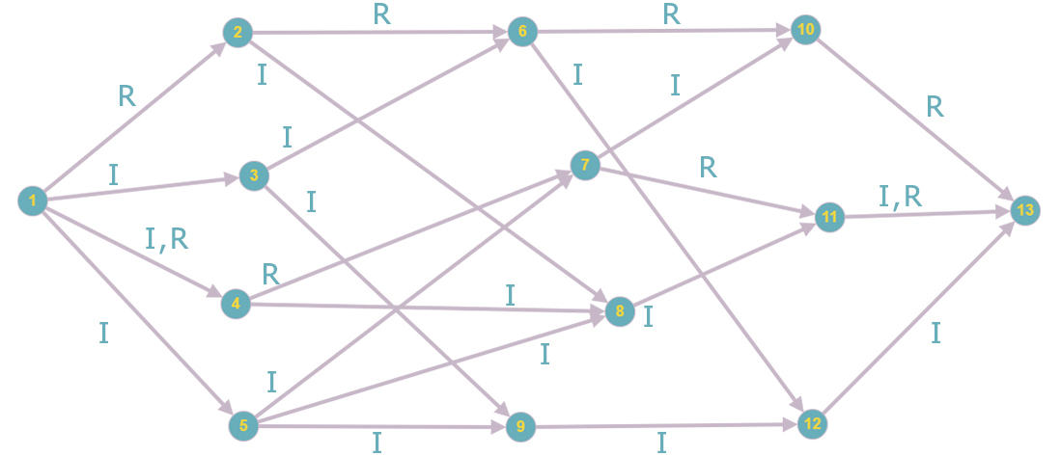

*Возьмем увеличивающий путь*

(x1, x4) (x4, x8) (x8, x11) (x11, x13)

*Найдем величину, на которую можно увеличить поток*

min {

i(x1, x4) = c(x1, x4) - f(x1, x4) = 3 - 1 = 2

i(x4, x8) = c(x4, x8) - f(x4, x8) = 1 - 0 = 1

i(x8, x11) = c(x8, x11) - f(x8, x11) = 2 - 0 = 2

i(x11, x13) = c(x11, x13) - f(x11, x13) = 6 - 0 = 6

} = 1

*Увеличим поток на данную величину*

f(x1, x4) = 1 + 1 = 2

f(x4, x8) = 0 + 1 = 1

f(x8, x11) = 0 + 1 = 1

f(x11, x13) = 0 + 1 = 1

*Распределим дуги по множествам*

f(x1, x4) = 2 ≠ c(x1, x4) =>(x1, x4) є I, R

f(x4, x8) = 1 = c(x4, x8) =>(x4, x8) є R

f(x8, x11) = 1 ≠ c(x8, x11) = 2 => (x8, x11) є I,R

f(x11, x13) = 1 ≠ c(x11, x13) = 6 => (x11, x13) є I,R

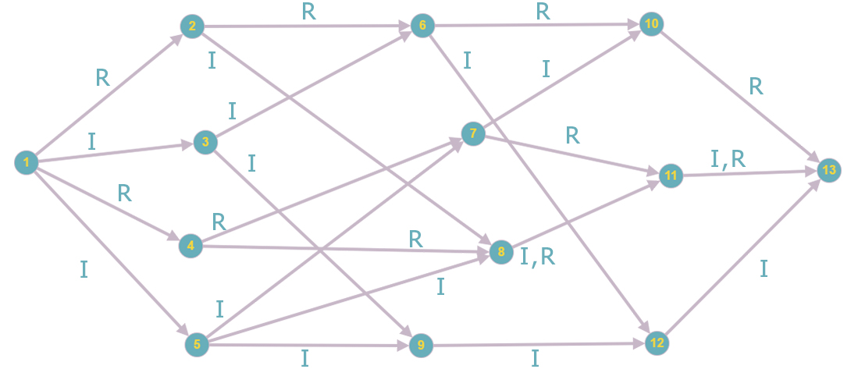

*Возьмем увеличивающий путь*

(x1, x4) (x4, x7) (x7, x11) (x11, x13)

*Найдем величину, на которую можно увеличить поток*

min {

i(x1, x4) = c(x1, x4) - f(x1, x4) = 3 - 2 = 1

i(x4, x7) = c(x4, x7) - f(x4, x7) = 2 - 1 = 1

i(x7, x11) = c(x7 x11) - f(x7, x11) = 4 - 0 = 4

i(x11, x13) = c(x11, x13) - f(x11, x13) = 6 - 1 = 5

} = 1

*Увеличим поток на данную величину*

f(x1, x4) = 2 + 1 = 3

f(x4, x7) = 1 + 1 = 2

f(x7, x11) = 0 + 1 = 1

f(x11, x13) = 1 + 1 = 2

*Распределим дуги по множествам*

f(x1, x4) = 3 = c(x1, x4) = 3 => (x1, x4) є R

f(x4, x7) = 2 = c(x4, x7) =>(x4, x7) є R

f(x7, x11) = 1 ≠ c(x7, x11) =>(x7, x11) є I, R

f(x11, x13) = 2 ≠ c(x11, x13) =>(x11, x13) є I, R

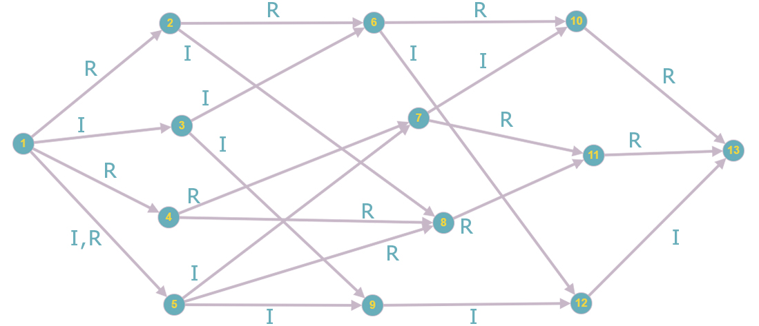

*Возьмем увеличивающий путь*

(x1, x5) (x5, x7) (x7, x11) (x11, x13)

*Найдем величину, на которую можно увеличить поток*

min {

i(x1, x5) = c(x1, x5) - f(x1, x5) = 3 - 0 = 3

i(x5, x7) = c(x5, x7) - f(x5, x7) = 3 - 0 = 3

i(x7, x11) = c(x7, x11) - f(x7, x11) = 4 - 1 = 3

i(x11, x13) = c(x11, x13) - f(x11, x13) = 6 - 2 = 4

} = 3

*Увеличим поток на данную величину*

f(x1, x5) = 0 + 3 = 3

f(x5, x7) = 0 + 3 = 3

f(x7, x11) = 1 + 3 = 4

f(x11, x13) = 2 + 3 = 5

*Распределим дуги по множествам*

f(x1, x5) = 3 = c(x1, x5) =>(x1, x5) є R

f(x5, x7) = 3 = c(x5, x7) =>(x5, x7) є R

f(x7, x11) = 4 = c(x7, x11) =>(x7, x11) є R

f(x11, x13) = 5 ≠ c(x11, x13) = 6 => (x11, x13) є I,R

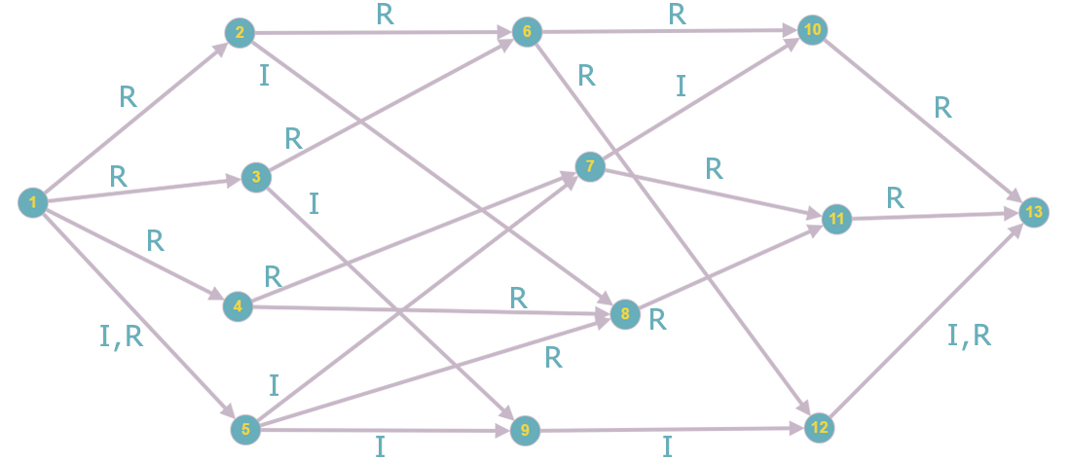

*Возьмем увеличивающий путь*

(x1, x2) (x2, x8) (x8, x11) (x11, x13)

*Найдем величину, на которую можно увеличить поток*

min {

i(x1, x2) = c(x1, x2) - f(x1, x2) = 2 - 1 = 1

i(x2, x8) = c(x2, x8) - f(x2, x8) = 1 - 0 = 1

i(x8, x11) = c(x8, x11) - f(x8, x11) = 2 - 1 = 1

i(x11, x13) = c(x11, x13) - f(x11, x13) = 6 - 5 = 1

} = 1

*Увеличим поток на данную величину*

f(x1, x2) = 1 + 1 = 2

f(x2, x8) = 0 + 1 = 1

f(x8, x11) = 1 + 1 = 2

f(x11, x13) = 5 + 1 = 6

*Распределим дуги по множествам*

f(x1, x2) = 2 = c(x1, x2) =>(x1, x2) є R

f(x2, x8) = 1 = c(x2, x8) =>(x2, x8) є R

f(x8, x11) = 2 = c(x8, x11) = 2 => (x8, x11) є R

f(x11, x13) = 6 = c(x11, x13) =>(x11, x13) є R

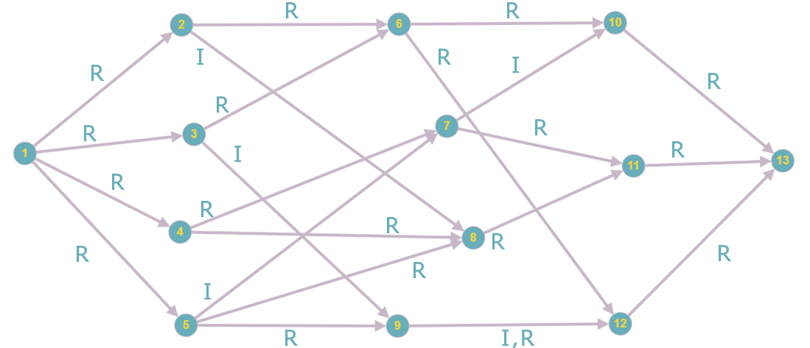

*Возьмем увеличивающий путь*

(x1, x3) (x3, x6) (x6, x12) (x12, x13)

*Найдем величину, на которую можно увеличить поток*

min {

i(x1, x3) = c(x1, x3) - f(x1, x3) = 1 - 0 = 1

i(x3, x6) = c(x3, x6) - f(x3, x6) = 1 - 0 = 1

i(x6, x12) = c(x6, x12) - f(x6, x12) = 1 – 0 = 1

i(x12, x13) = c(x12, x13) - f(x12, x13) = 4 - 0 = 4

} = 1

*Увеличим поток на данную величину*

f(x1, x3) = 0 + 1 = 1

f(x3, x6) = 0 + 1 = 1

f(x6, x12) = 0 + 1 = 1

f(x12, x13) = 0 + 1 = 1

*Распределим дуги по множествам*

f(x1, x3) = 1 = c(x1, x3) =>(x1, x3) є R

f(x3, x6) = 1 = c(x3, x6) =>(x3, x6) є R

f(x6, x12) = 1 = c(x6, x12) = 1 => (x6, x12) є R

f(x12, x13) = 1 ≠ c(x12, x13) =>(x12, x13) є I, R

*Разрез при конечной вершине насыщенный, следовательно, закончить алгоритм*

*Пройденные пути*

(x1, x2) (x2, x6) (x6, x10) (x10, x13) – 1

(x1, x4) (x4, x7) (x7, x10) (x10, x13) – 1

(x1, x4) (x4, x8) (x8, x11) (x11, x13) – 1

(x1, x4) (x4, x7) (x7, x11) (x11, x13) – 1

(x1, x5) (x5, x7) (x7, x11) (x11, x13) – 3

(x1, x2) (x2, x8) (x8, x11) (x11, x13) – 1

(x1, x3) (x3, x6) (x6, x12) (x12, x13) – 1

***Максимальное увеличение потока равно* 9.**

Минимальный поток:



Нахождение минимального потока из x1 в x13

Полагаем, что все вершинные числа равны 0

p(x1) = … = p(x13) = 0

Все вершины не окрашены за исключением вершины x1

f(x,y) = 0 (x,y)

Сформируем множества I, R, N

p(x2) – p(x1) = 0 a(x1,x2) = 1, f(x1,x2) = 0 N

……………………….

p(x13) – p(x12) = 0 a(x12,x13) = 3, f(x12,x13) = 0 N

Все дуги относятся к множеству N, а поэтому применить алгоритм поиска максимального потока нельзя.

Увеличиваем вершинные числа неокрашенных вершин на единицу.

p(x1) = 0 p(x2) = … = p(x13) = 0 + 1 = 1

Повторяем шаг 2. Формируем множества I, R, N

p(x2) – p(x1) = 1 – 0 = 1 = a(x1, x2) = 1, f(x1,x2) = 0 I

p(x3) – p(x1) = 1 – 0 = 1 = a(x1, x3) = 1, f(x1,x3) = 0 I

p(x4) – p(x1) = 1 – 0 = 1 a(x1, x4) = 3, f(x1,x4) = 0 N

p(x5) – p(x1) = 1 – 0 = 1 a(x1, x5) = 3, f(x1,x5) = 0 N

……………………….

p(x13) – p(x12) = 1 – 1 = 0 a(x12, x13) = 3, f(x12,x13) = 0 N

*Выполним результирующее окрашивание вершин.*

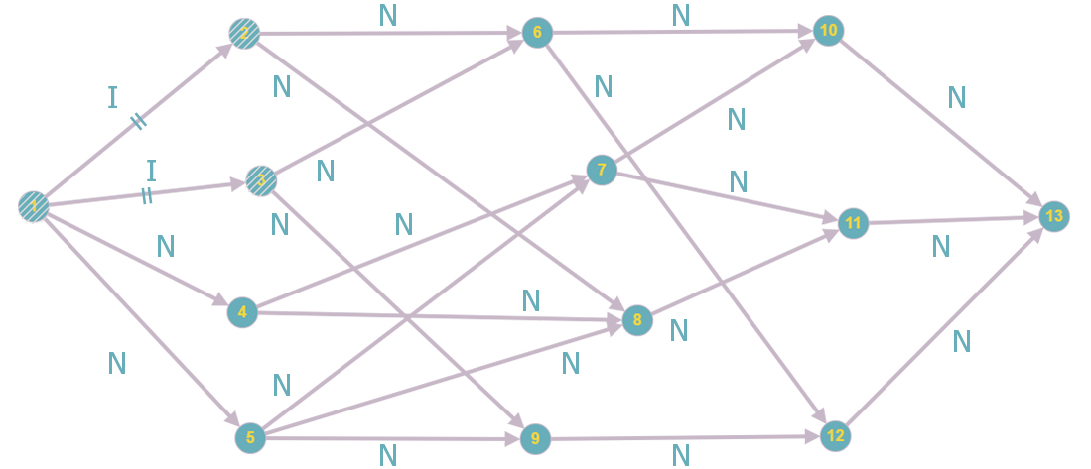

Максимальный поток найти не удается. Увеличим вершинные числа неокрашенных вершин на единицу.

p(x1) = 0 p(x2) = p(x3) = 1 p(x4) = p(x5) = … = p(x13) = 1 + 1 = 2

p(x4) – p(x1) = 2 – 0 = 2 a(x1, x4) = 3, f(x1,x4) = 0 N

p(x5) – p(x1) = 2 – 0 = 2 a(x1, x5) = 3, f(x1,x5) = 0 N

p(x6) – p(x2) = 2 – 1 = 1 = a(x2, x6) = 1, f(x2,x6) = 0 I

p(x8) – p(x2) = 2 – 1 = 1 = a(x2, x8) = 1, f(x2,x8) = 0 I

p(x6) – p(x3) = 2 – 1 = 1 = a(x3, x6) = 1, f(x3,x6) = 0 I

p(x9) – p(x3) = 2 – 1 = 1 = a(x3, x9) = 1, f(x3,x9) = 0 I

……………………….

p(x13) – p(x12) = 2 – 2 = 0 a(x12, x13) = 3, f(x12,x13) = 0 N

*Выполним результирующее окрашивание.*

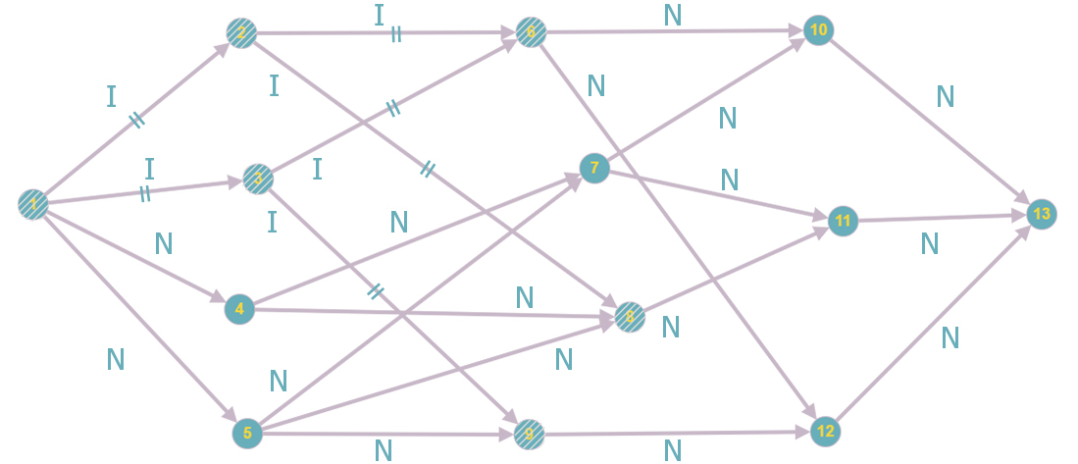

Максимальный поток найти не удается. Увеличим вершинные числа неокрашенных вершин на единицу.

p(x1) = 0 p(x2) = p(x3) = 1 p(x6) = p(x8) = p(x9) = 2 p(x4) = p(x5) = p(x7) = … = p(x13) = = 2 + 1 = 3

p(x4) – p(x1) = 3 – 0 = 3 = a(x1, x4) = 3, f(x1,x4) = 0 I

p(x5) – p(x1) = 3 – 0 = 3 = a(x1, x5) = 3, f(x1,x5) = 0 I

p(x8) – p(x4) = 2 – 3 = -1 a(x4, x8) = 1, f(x4,x8) = 0 N

p(x7) – p(x4) = 3 – 3 = 0 a(x4, x7) = 2, f(x4,x7) = 0 N

p(x7) – p(x5) = 3 – 3 = 0 a(x5, x7) = 3, f(x5,x7) = 0 N

p(x8) – p(x5) = 2 – 3 = -1 a(x5, x8) = 1, f(x5,x8) = 0 N

p(x9) – p(x5) = 2 – 3 = -1 a(x5, x9) = 2, f(x5,x9) = 0 N

p(x10) – p(x6) = 3 – 2 = 1 = a(x6, x10) = 1, f(x6,x10) = 0 I

p(x12) – p(x6) = 3 – 2 = 1 = a(x6, x12) = 1, f(x6,x12) = 0 I

……………………….

p(x13) – p(x12) = 3 – 3 = 0 a(x12, x13) = 3, f(x12,x13) = 0 N

*Выполним результирующие окрашивание.*

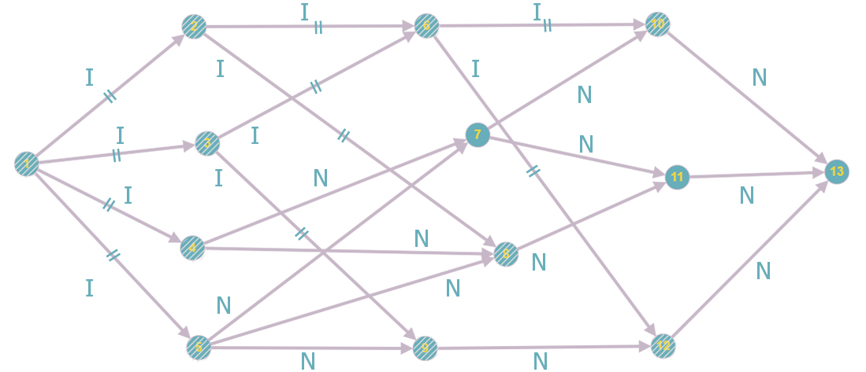

Максимальный поток найти не удается. Увеличим вершинные числа неокрашенных вершин на единицу.

p(x1) = 0 p(x2) = p(x3) = 1 p(x6) = p(x8) = p(x9) = 2 p(x4) = p(x5) = p(x10) = p(x12) = = 3 p(x7) = p(x11) = p(x13) = 3 + 1 = 4

p(x7) – p(x4) = 4 – 3 = 1 a(x4, x7) = 2, f(x4,x7) = 0 N

p(x7) – p(x5) = 4 – 3 = 1 a(x5, x7) = 3, f(x5,x7) = 0 N

p(x13) – p(x10) = 4 – 3 = 1 = a(x10, x13) = 1, f(x10,x13) = 0 I

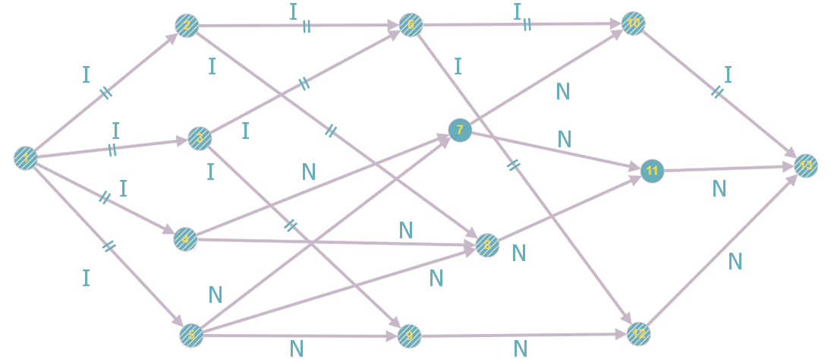

Min {i(x1,x2), i(x2,x6), i(x6, x10), i(x10,x13)} min{2,1,1,3} = 1

f(x1,x2) = f(x2,x6) = f(x6,x10) =f(x10,x13) = 1

p(x1) = 0 p(x2) = p(x3) = 1 p(x6) = p(x8) = p(x9) = 2 p(x4) = p(x5) = p(x10) = p(x12) = 3

p(x11) = p(x13) = p(x7) = 4

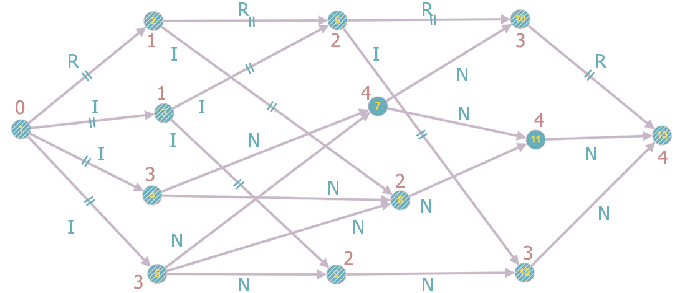

Существует единственный путь, по которому мы могли бы попасть из x1 в x13. Так как по остальным путям мы не можем попасть в x13.

Все ребра на этом пути равны R, следовательно, мы нашли минимальный поток.

**p = 4.**